**MySQL Exercise 5**

1.

DELIMITER //

CREATE FUNCTION is_valid_triangle(a FLOAT, b FLOAT, c FLOAT)

RETURNS BOOLEAN

DETERMINISTIC

BEGIN

DECLARE is_valid BOOLEAN;

-- Check the triangle inequality theorem

IF a + b > c AND a + c > b AND b + c > a THEN

SET is_valid = TRUE;

ELSE

SET is_valid = FALSE;

END IF;

RETURN is_valid;

END //

DELIMITER ;

-- Example usage of the function

SELECT is_valid_triangle(3, 4, 5) AS is_valid; -- This should return true

SELECT is_valid_triangle(1, 2, 3) AS is_valid; -- This should return false

SELECT is_valid_triangle(5, 10, 12) AS is_valid; -- This should return true

SELECT is_valid_triangle(7, 3, 2) AS is_valid; -- This should return false

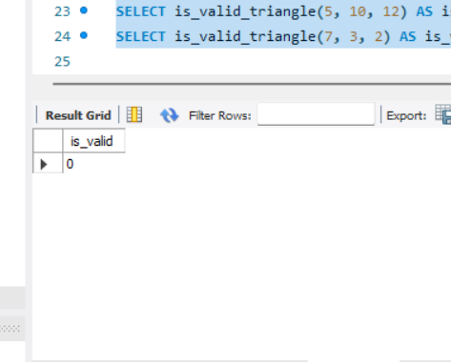

2.

DELIMITER //

CREATE FUNCTION generate_random_number()

RETURNS INT

DETERMINISTIC

BEGIN

DECLARE random_number INT;

-- Generate a random number between 1 and 10

SET random_number = FLOOR(1 + (RAND() * 10));

RETURN random_number;

END //

DELIMITER ;

-- Example usage of the function

SELECT generate_random_number() AS random_number;

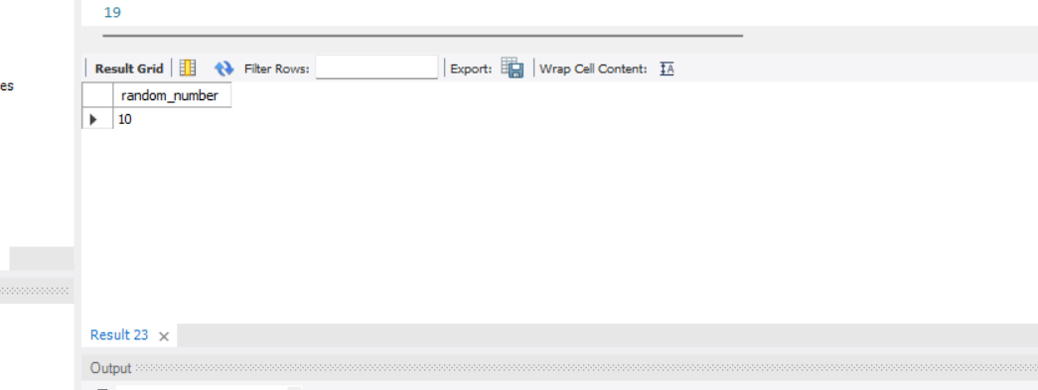

3.

CREATE FUNCTION reverse_string(input_string VARCHAR(255)) RETURNS VARCHAR(255) BEGIN DECLARE reversed_string VARCHAR(255); DECLARE i INT DEFAULT 1; DECLARE length INT DEFAULT LENGTH(input_string);

WHILE i <= length DO

SET reversed_string = CONCAT(reversed_string, SUBSTRING(input_string, length - i + 1, 1));

SET i = i + 1;

END WHILE;

RETURN reversed_string;

END;